Installation of ant in mac

- Open the terminal
- Type following command to install brew
ruby -e "$(curl -fsSL https://raw.githubusercontent.com/Homebrew/install/master/install)"

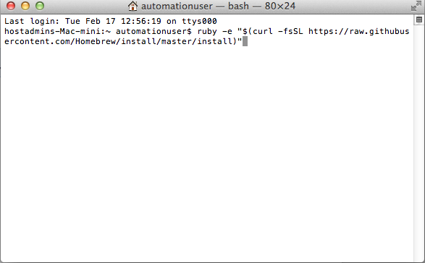

After installation of brew

- Type the following commands in terminal
  - brew update
  - brew install ant

After installation of ant is done type :- ant -version in terminal , ant version should be displayed
